Smart Energy Learning Centre (SELC)
Dhirubhai Ambani University, Gandhinagar
RESEARCH & DEVELOPMENT PROPOSAL
FairAC: An IoT-Based Smart Energy Management Platform for Shared Living Spaces
Proposal to join SELC as a Part-Time Research Fellow and extend FairAC into a validated energy-conservation research platform
Applicant | Dhrumil Rajeshbhai Doshi
Enrollment No. | 202512088
Programme | M.Sc. (Information Technology), Dhirubhai Ambani University
Proposed Guide | Abhishek Jindal
Department / Centre | Smart Energy Learning Centre (SELC)
Date | 07/08/2026
Contact | 202512088@dau.ac.in | dhrumildoshidd114@gmail.com | 8238781783

Table of Contents
1. Executive Summary 3
2. Introduction & Background 4
3. Problem Statement 5
4. Existing Systems & Literature Review 6
5. Objectives & Research Questions 7
6. Proposed System — FairAC Overview 8
7. Novelty & Innovation 10
8. Energy Efficiency & Conservation Contribution 11
9. Alignment with SELC's Research Themes 15
10. Research Methodology & Experimental Plan 17
11. Expected Outcomes 18
12. Market Relevance & Commercialization Potential 19
13. Resource & Support Requirement 20
14. Timeline 25
15. Risk Analysis & Mitigation 26
16. Future Scope 27
17. Conclusion 28
References 29
Appendix A: System Architecture Diagram 30
Appendix B: Version 3.0 Hardware Roadmap (Not Yet Developed) 31

1. Executive Summary
FairAC is a full-stack, IoT-integrated energy management platform originally developed to solve unfair AC electricity billing in shared hostel and PG accommodations, where costs are conventionally split equally among roommates regardless of actual usage. The system meters real consumption per session using a PZEM-004T sensor on an ESP32 controller, and splits the resulting cost proportionally among participants down to the second, using an offline-first architecture (Bluetooth Low Energy) so it keeps working even when hostel Wi-Fi is unavailable.
This proposal requests SELC's support to extend FairAC from a working fair-billing system into a validated energy-conservation research platform, in line with SELC's mission of connecting IoT, data, and engineering to real-world energy outcomes. Two conservation mechanisms are already part of the system's design — usage-capped sessions, and short-cycle protection for compressor safety — and this proposal identifies the primary new R&D items: automatic standby-power isolation (deployable on today's offline hardware) and true anywhere-remote session control (which requires the online-connected Hub tier described in Appendix B, not yet built), alongside an experimental plan to move the project's energy-saving claims from qualitative reasoning to measured evidence.
The proposal is intentionally scoped to what is achievable by a part-time student research fellow over a 6–9 month window: hardening one new hardware feature, running a small-scale pilot, and producing a defensible, evidence-based account of FairAC's energy impact — rather than a large-scale claim that cannot yet be supported.

2. Introduction & Background
Air conditioners are among the most power-intensive appliances in shared student accommodation, and in most hostels and PGs, the electricity cost of running them is split equally among roommates irrespective of who actually used the appliance and for how long. FairAC was originally developed as a summer internship project to address the fairness dimension of this problem: it meters actual AC usage per session and bills participants proportionally, using a wallet-based system on a mobile app connected to a purpose-built IoT controller.
Since then, the system has grown into a working, end-to-end platform spanning custom IoT firmware, a transaction-safe backend, and a React Native mobile application, and has been documented as a completed internship deliverable. Independently of the billing problem, a review of the system's behaviour with a faculty member working in SELC surfaced a related and distinct question: beyond making billing fair, does FairAC's architecture also reduce actual energy consumption? This proposal is a direct response to that question, and to the opportunity SELC has extended to develop FairAC further as a funded research project.
Dhirubhai Ambani University's Smart Energy Learning Centre (SELC) is a CSR-funded research centre focused on modern energy technologies — smart grids, IoT-based energy monitoring, data analytics, and utility-driven smart services — with an explicit emphasis on work that is deployed and used, not confined to publication. FairAC's problem area, technical approach, and deployment orientation overlap substantially with this mission, which is the basis for this proposal.

3. Problem Statement
This proposal addresses two related but distinct problems:

3.1 The Fairness Problem (already substantially solved by FairAC)
Equal-split billing in shared AC usage creates a persistent incentive misalignment: occupants who use the AC sparingly subsidise those who use it heavily, with no transparent record of individual consumption. This is a trust and equity problem, and it is the problem FairAC was originally built to solve.

3.2 The Energy Conservation Problem (the focus of this proposal)
A separate, related problem is that traditional AC usage in shared rooms has no structural limit or accountability mechanism: an AC can be left running indefinitely if a student forgets to switch it off, and it continues drawing standby power even after being switched off by a traditional infrared remote, since the remote does not disconnect mains power to the unit. On today's offline-first hardware (Section 6, Appendix B.2–B.3), a student who has left the room and gone out of Bluetooth range cannot stop that session instantly from a distance — they can only wait for the session's own usage cap to end it, or return within Bluetooth range. Under equal-split billing, no individual bears the direct cost of this waste either, which further reduces the incentive to conserve. FairAC's existing session-based architecture already addresses part of this through usage caps, but the system has not yet been evaluated or extended specifically as an energy-conservation mechanism — which is the gap this proposal is designed to close.

4. Existing Systems & Literature Review
Before proposing this work, the existing landscape was reviewed to understand what has already been solved, and specifically where FairAC's contribution is genuinely novel rather than a re-implementation of an existing product.

4.1 Manual and Social Bill-Splitting
The default practice in most shared accommodations remains equal division of the electricity bill, sometimes supplemented by informal negotiation or general-purpose bill-splitting apps. These approaches address the accounting problem but have no metering component and therefore no ability to influence actual consumption behaviour.

4.2 Room-Level IoT Prepaid Submetering
Commercial products such as Encharge (by Enlog) and offerings from Aliste Technologies already provide IoT-based prepaid electricity submetering for PG and hostel rooms in the Indian market, with auto-recharge and real-time dashboards positioned specifically to reduce tenant-landlord billing disputes. These systems meter and bill at the level of an entire room, not at the level of an individual person's use of a single shared appliance — which is the specific gap FairAC addresses.

4.3 Pay-Per-Use AC Services
Haier has deployed an IoT-enabled "Smart Sharing AC" service in the Indian hostel market, allowing a single user to pay for AC usage via QR code with real-time monitoring. This is the closest existing commercial product to FairAC's pay-as-you-use principle, but it is built around a single payer per use, without a mechanism for dynamically splitting one running session's cost across multiple simultaneous or sequential participants.

4.4 Academic Prior Art
Related academic work has proposed shared-apartment billing systems using a similar hardware approach (a PZEM-family energy sensor with a microcontroller and a communication module) to attribute energy cost fairly across occupants of a shared space. This validates the core hardware approach FairAC uses, but such work typically attributes cost at the level of a room or apartment via GSM/SMS communication, rather than at the level of an individual's exact participation time within one shared-appliance session, and does not use an offline-first BLE architecture. `[NOTE: exact citation details for this and other academic sources should be verified and completed before formal submission — see the flagged entries under References.]`

4.5 Summary of the Gap
No system identified in this review combines: (a) proportional cost-splitting within a single shared-appliance session based on exact participation time, (b) fully offline-first operation independent of Wi-Fi/GSM availability, and (c) financial and hardware fault-tolerance suitable for unattended, real-money deployment. This combination is the specific contribution FairAC offers, and the basis for treating it as a genuine research artifact rather than a reimplementation of existing products.

5. Objectives & Research Questions

5.1 Objectives
- Extend FairAC's existing fair-billing system with a validated, measurable energy-conservation mechanism (automatic standby-power isolation).
- Design and execute a small-scale pilot to collect real usage and energy data under FairAC, rather than relying on architectural reasoning alone.
- Produce an interactive energy visualization layer from FairAC's session data, aligned with SELC's existing research direction in this area.
- Harden the safety-critical restart-lockout mechanism from a server-side check to a firmware-enforced guarantee, independent of network or app state.
- Establish a defensible, evidence-based account of FairAC's actual energy impact, distinguishing what can be claimed today from what requires further data.

5.2 Research Questions
- RQ1: Does individual, session-based energy attribution reduce aggregate AC energy consumption in shared rooms, compared to equal-split billing?
- RQ2a: On today's offline-first hardware, do usage caps alone (without true remote termination) meaningfully limit unnecessary AC operation after occupants leave?
- RQ2b: Does adding true anywhere-remote termination — only possible via the online-connected Hub tier (Appendix B.4), not yet built — produce a further, measurable reduction beyond what usage caps and standby-isolation already achieve?
- RQ3: How much standby energy can realistically be eliminated through automatic post-shutdown power isolation, and what threshold power/duration reliably distinguishes "off but still drawing standby power" from "briefly idling mid-use"?
- RQ4: Does real-time visibility into individual usage and cost change discretionary AC usage patterns over the course of a pilot deployment?
- RQ5 (future work): Can FairAC's historical session data support predictive, occupancy-aware scheduling or optimization models?

6. Proposed System — FairAC Overview
FairAC is architected as a three-tier, offline-first system so that it continues to function during the network outages common in hostel Wi-Fi environments.

6.1 Architecture Summary
- IoT Edge Layer (ESP32 + C++ firmware): reads real power draw via a PZEM-004T sensor, drives the AC through a relay, runs a fault-tolerant state machine (BOOTING → STANDBY → SESSION_ACTIVE → FINISHED → FAULT), and persists session state to NVS flash to survive power interruptions.
- Mobile Bridge Layer (React Native / Expo): connects to the ESP32 directly over Bluetooth Low Energy when offline, and to the cloud backend over HTTPS when connectivity is available.
- Cloud Backend Layer (Node.js / Express + PostgreSQL): owns all financial logic — wallets, time-proportional billing, and session records — enforced through database-level constraints and transaction-safe, row-level-locked operations.

6.2 Current Capability vs. Proposed R&D Scope
To keep this proposal's claims precise, the table below distinguishes what FairAC already does from what this proposal requests SELC's support to build and validate.
Capability | Status
Session booking by Duration / Units / Amount | Implemented
Time-proportional multi-user split billing | Implemented
Offline-first BLE session control | Implemented
NVS-based power-cut recovery (financial + session state) | Implemented
Automatic session termination at usage limit | Implemented
Local session stop via Bluetooth (student within BLE range) | Implemented
True anywhere-remote session stop (e.g., from college) | Not possible on current offline-first hardware; requires the online-connected Hub tier (Appendix B.4), which is proposed and not yet built
Hardware emergency-stop button | Implemented
Restart lockout (short-cycle / compressor protection) | Implemented server-side; firmware-level enforcement proposed as a hardening item (Section 8, 15)
Automatic standby-power isolation after remote power-off | Implemented  Proposed — primary new R&D item (Phase 1); does not require online connectivity, so deployable on current offline-first hardware
Reward-based incentive for controlled/moderate usage | Proposed — Phase 2, contingent on RQ4 pilot findings (Section 8.6)
Real-time single-session visualization (live power, kWh, cost, room-split) — mobile app | Implemented (Section 9.1)
Historical / comparative energy visualization dashboard (trends, room comparisons, peak usage) | Proposed — Phase 1–2, aligned with SELC's existing visualization research (Section 9.1)
Occupancy-based predictive scheduling (ML) | Proposed — future work (Section 16)
"Duo" / "Floor Hub" multi-room hardware tiers (Version 3.0) | Proposed — future hardware roadmap, not yet developed (Appendix B); both tiers, including Duo, are treated as not yet built
Android mobile app — core functionality | Implemented; UI/UX under active, ongoing revision rather than finalized
iOS mobile app | Proposed — not yet built; planned to reuse the existing React Native codebase rather than a separate rewrite
Payment Gateway Integration | NOT done YET!

6.3 System Architecture Diagram
A detailed architecture diagram is provided in Appendix A.

6.4 Scaling Beyond a Single Room
Everything described above is the single-room "Micro" configuration currently deployed and the basis of the pilot proposed in Section 10. A broader, multi-tier hardware architecture — supporting shared two-room deployments and a centralized, Ethernet-based hub for 10–15 rooms — has been designed at the blueprint stage but is not yet built or tested. That roadmap is described separately in Appendix B, and is deliberately kept out of this proposal's core scope and budget request, since committing pilot resources to unbuilt, larger hardware before the single-room mechanisms are validated would be premature.

7. Novelty & Innovation
- Session-level, multi-party proportional billing: cost is split dynamically across participants based on their exact join/leave time within a single shared-appliance session — a mechanism not found in the room-level submetering or single-payer pay-per-use products reviewed in Section 4.
- Offline-first, BLE-based control: the system remains fully operational without Wi-Fi, using the student's phone as a secure bridge between offline hardware and the cloud, rather than depending on continuous connectivity as most comparable systems do.
- Financial and hardware fault tolerance: NVS-based power-cut recovery, database-level financial safety constraints, and (proposed) firmware-enforced restart lockout make the system suitable for unattended, real-money deployment rather than a lab demonstration.
- Conservation-by-design, not conservation-by-add-on: usage caps are a structural property of the session model itself — not a separate feature bolted onto a billing system — and this holds even on today's offline-first hardware, without requiring persistent internet connectivity.

8. Energy Efficiency & Conservation Contribution
This section is deliberately its own chapter, since it is the primary lens through which SELC evaluates project fit. It separates mechanisms already built into FairAC from the mechanism proposed as new R&D work under this proposal, and it distinguishes defensible qualitative claims from claims that require pilot evidence.

8.1 Mechanism 1 — Usage-Capped Sessions (Implemented)
Unlike traditional AC usage, which continues indefinitely until manually switched off, every FairAC session has a bound — by duration, energy units, or wallet amount — set at booking time. This structurally prevents the unbounded, unaccountable runtime that is common in equal-split billing arrangements.

8.2 Mechanism 2 — Session Termination: Local Today, True Remote Proposed
A student within Bluetooth range of the device can terminate an active session from the mobile app today — this is implemented and working. However, because the current Micro and (proposed) Duo tiers are offline-first by design (Appendix B.2–B.3), a student who has left the room and gone out of Bluetooth range — for example, to college, as in the motivating scenario for this feature — cannot stop that session instantly from a distance on today's hardware. In that situation, the only mechanisms that actually limit the waste are the usage cap ending the session automatically (Mechanism 1) and, pending Phase 1 development, standby-power isolation once the session ends (Mechanism 3). True anywhere-remote termination requires persistent online connectivity, which only the proposed Hub tier (Appendix B.4, Ethernet-connected) provides, and that tier has not yet been built.
This is stated plainly here because it directly affects how this proposal's other mechanisms should be read: on the hardware that exists today, usage caps and standby-isolation are not merely convenient additions alongside remote control — they are the primary defence against a forgotten AC, precisely because true remote control is not yet available. This also motivates RQ2a/RQ2b in Section 5.2, which separate what usage caps alone achieve from what true remote termination would add once the Hub tier exists.

8.3 Mechanism 3 — Automatic Standby-Power Isolation (Proposed, Phase 1 R&D)
Presently, when an AC is switched off using its own infrared remote, the indoor unit's control board typically remains connected to mains power and continues to draw a small standby current. This proposal's primary new technical contribution is to have the ESP32 continuously monitor real power draw via the PZEM-004T sensor even outside an active FairAC session; if the measured draw remains below a calibrated threshold for a sustained period — indicating the unit has been switched off at the remote but is still drawing standby power — the system will fully open the relay and isolate mains power, eliminating that residual draw entirely.
Published measurements of split-AC standby draw vary by unit and study — one standby-power survey measured an average of roughly 2 W in "off" mode and up to about 11 W in "passive standby" mode, and other sources report a broader 1–10 W range. Taking a representative ~2–10 W range across 24 hours implies roughly 48–240 Wh of avoidable standby energy per unit per day, which this proposal treats as an order-of-magnitude estimate to be replaced with figures measured directly from the pilot units (Phase 1), not a number to cite as established fact. `[VERIFY: confirm exact source and figures before formal submission — see References.]`
Note on the threshold: rather than fixing a specific power and duration value (e.g., a particular wattage sustained for a particular number of minutes) in advance, this proposal treats that threshold as an empirical calibration task — Phase 1 of the methodology in Section 10 — to be determined through bench testing against real AC standby-draw behaviour, so that the feature reliably distinguishes "switched off but still drawing standby power" from a brief idle period during active use.

8.3.1 Safety caveat this proposal takes seriously: crankcase heaters
Some AC units — more commonly larger, ducted, or certain inverter systems, though this varies by manufacturer and model — use a small "crankcase heater" that keeps the compressor oil warm while the unit is nominally off, specifically to prevent compressor damage on the next startup. At least one major manufacturer's guidance states that if such a unit is powered off at the mains, it should not be restarted for approximately 12 hours, to allow the crankcase heater to bring the compressor back to a safe operating temperature. This matters directly for this proposal: fully isolating mains power for standby-power savings could, on a unit with a crankcase heater, recreate exactly the kind of compressor-startup risk the restart-lockout mechanism (Section 6.2, Mechanism in Section 8.7) is designed to prevent, if the unit is restarted too soon afterward.
This proposal treats that as an open question to resolve before deployment, not a settled non-issue: Phase 1 (Section 10) will include confirming whether the specific AC models used in the pilot have a crankcase heater or equivalent (via manufacturer documentation, not assumption), and if so, either restricting standby-isolation to units without one, or extending the post-isolation restart delay well beyond the existing 5-minute short-cycle lockout to a duration appropriate for that unit's warm-up requirement.

8.4 Mechanism 4 — Behavioural Change Through Individual Accountability
Under equal-split billing, no individual bears the direct cost of their own AC usage, which weakens the incentive to conserve. Utility-scale research on consumption feedback has broadly found that increased visibility into individual usage tends to reduce discretionary consumption. FairAC's session-based, individually attributed billing is structurally positioned to produce a similar effect at the level of a shared room, though this proposal treats that as a hypothesis to be tested (RQ4), not an established fact about FairAC specifically.

8.5 Alignment with SELC's Visualization-Focused Research Direction
FairAC already generates the kind of granular, session-level data — power, energy, duration, per-participant usage, historical trends — that is well suited to interactive, real-time energy visualization work, a recurring direction in SELC's published research priorities. Turning that data into an interactive dashboard (Section 6.2, Phase 1–2 of Section 10) is a direct, low-risk extension point that builds on capability FairAC already has (Section 9.1).

8.6 Proposed Enhancement — Reward-Based Incentive for Controlled Usage
As a further extension of Mechanism 4, this proposal suggests a reward-points layer on top of FairAC's wallet system: sessions that end with below-threshold average consumption, or that use timer-bound/eco-conscious booking options, could accrue points redeemable against future wallet top-ups. The intent is to reinforce the same behavioural-accountability effect Mechanism 4 targets, but with a more immediate, visible incentive rather than relying solely on cost-awareness. This is proposed as a Phase 2 feature, deliberately sequenced after RQ4 is evaluated with real pilot data — if fair billing alone does not measurably change usage patterns, a reward layer addresses a different problem than tuning its parameters would, and that sequencing keeps the proposal from adding complexity ahead of evidence that it is needed.

8.7 Sustainability Framing: Compressor Protection as E-Waste Reduction
FairAC's existing restart-lockout mechanism (Section 6.2) was originally designed to prevent short-cycling damage to AC compressors — restarting a compressor before refrigerant pressure has equalised draws excessive current and, over repeated instances, shortens compressor life. Reframed through a sustainability lens relevant to SELC's stated focus areas (which include "Recycle & Reuse" and "Sustainability"): protecting compressor lifespan is not only a hardware-safety concern but also an e-waste reduction mechanism — a compressor failure is one of the most common reasons a functioning AC unit is prematurely discarded rather than repaired. This reframing does not change the underlying engineering; it identifies an existing safety feature as also being a legitimate environmental-impact contribution, which this proposal considers worth stating explicitly rather than leaving implicit.

8.8 Sustainability Framing (continued): Electronics Footprint & Recurring-Cost Reduction

8.8.1 Hardware consolidation at the Floor Hub tier
Each AC still needs one point of sensing — that requirement does not go away. What conventional per-AC smart submetering duplicates unnecessarily is everything around that sensor: a complete, self-contained device per room, each with its own microcontroller, its own communication module, its own display, its own enclosure and power supply. For 10–15 rooms, that means 10–15 independent “brains” for a job that only ever needed one. The proposed Floor Hub (Appendix B.4) separates sensing from intelligence: the PZEM-016 units are bare sensing elements with no microcontroller, radio, or enclosure of their own, daisy-chained back to a single controller that holds the only microcontroller, the only communication module, and the only enclosure for up to 15 rooms. In short, the requirement for 10–15 separate smart-meter units is reduced to one single unit, without reducing how many points are actually metered. This is a genuine, defensible reduction in electronics production and eventual e-waste per room metered, when compared specifically against smart/IoT submetering products (Section 4.2). The comparison is weaker against basic, non-smart electromechanical submeters, which have little or no “brain” hardware to consolidate in the first place, and this proposal is careful to scope the claim accordingly.

8.8.2 Removing standalone per-device cellular connectivity
This is not a hypothetical pattern — it is what is currently installed in the applicant's own hostel. The photograph below is of the traditional prepaid smart submeter installed for a single AC there: a Visiontek SM-14 AC Static kWh Smart Meter, whose label states “WAN Comm.: Cellular (850/900/1800/2100/2300/2500 MHz)” with a printed IMEI, confirming it communicates over a dedicated cellular connection rather than the building's Wi-Fi, even where Wi-Fi is available. As a prepaid cellular-connected device, its ongoing data connectivity is bound to a recharge cycle in the same way its electricity credit is, which is a real, recurring cost tied to metering infrastructure the student did not choose and is unlikely to itemise or notice.
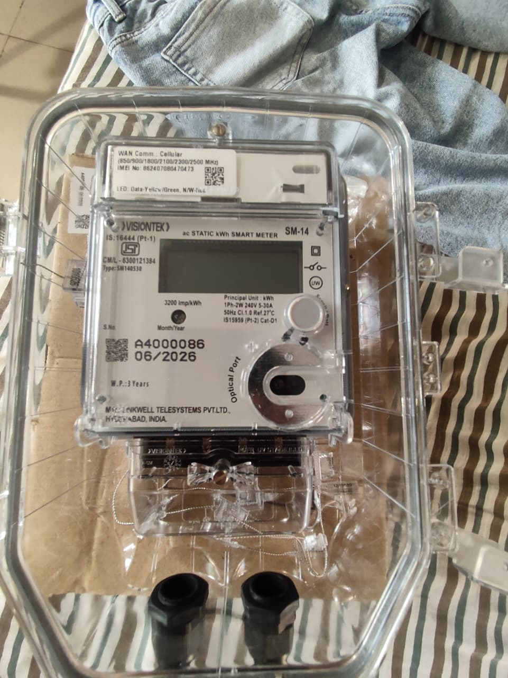
Figure: Traditional single-AC prepaid smart submeter installed in the applicant's hostel (Visiontek SM-14), showing “WAN Comm.: Cellular” and a printed IMEI on its label — first-hand evidence of the per-device cellular dependency described here.
More broadly, standalone IoT metering products that need connectivity independent of a building's own network (to avoid depending on landlord-controlled Wi-Fi credentials, coverage gaps, or a password change silently breaking the device) commonly use this same dedicated GSM/cellular approach. FairAC's architecture avoids this dependency structurally rather than by pricing: its offline-first design bridges connectivity through the student's own smartphone — which already carries its own data plan — so FairAC's IoT hardware requires no standalone cellular connectivity or SIM card at any tier, including the Ethernet-based Floor Hub, which uses the building's wired network instead. `[VERIFY: the photographed Visiontek device is first-hand evidence and does not itself need verification; however, this proposal has not independently confirmed that the specific named competitor products discussed elsewhere (Encharge, Aliste, Section 4.2) use the same cellular/SIM approach rather than Wi-Fi — that broader claim remains a common-pattern inference, not a verified statement about those companies specifically.]`

8.9 Claims This Proposal Will Not Make Without Evidence
To keep this proposal credible to a research audience, it deliberately avoids quantitative energy-savings claims (for example, a specific percentage reduction in consumption) until such figures are supported by pilot data collected under the methodology in Section 10. Until then, the defensible claims are qualitative and mechanism-based: FairAC enables local, BLE-range session shutdown today (Section 8.2) and structurally caps every session's runtime, eliminating indefinite operation; anywhere-remote shutdown is a proposed capability pending the Hub tier, not a claim made about today's hardware; and — pending Phase 1 development and the crankcase-heater validation in Section 8.3.1 — the system is designed to eliminate standby power draw and support real-time usage feedback.

9. Alignment with SELC's Research Themes
SELC's published research themes include Intelligent Energy Systems, IoT Solutions for Energy Monitoring, Data Analytics, Utility-Driven Smart Services, and Sustainability — with a consistent emphasis across its project portfolio on solving a real-world energy problem using IoT, data, and engineering, and on work that is intended for real deployment rather than remaining a lab prototype. FairAC's functionality lines up with these themes directly, on its own evidence, without needing to be compared against any specific existing project to make the case.

9.1 Real-Time Personal Energy Visualization — Evidence Already in Hand
A recurring direction in SELC's published research priorities is interactive, real-time visualization of personal energy usage — giving users access to live consumption metrics, individual usage tracking, and engagement features (such as gamified elements) that encourage more responsible consumption. FairAC's mobile app already delivers a working version of exactly this today, not as a future promise: the current session screen (Figure below) shows a real-time live power reading, session-level energy consumption (kWh), running cost, and a proportional room-split view among participants.
This proposal treats that existing screen as concrete, working evidence of alignment, and proposes extending it (Section 10, Phase 4) with the historical, comparative, and trend-based views — daily/monthly usage trends, room comparisons, peak-usage patterns, and standby-energy visualization once Section 8.3 is built — that the current single-session view does not yet cover.
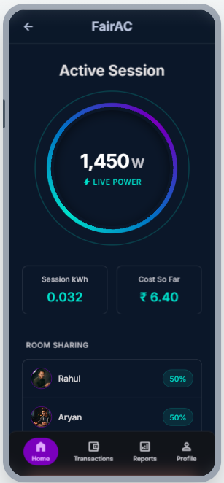
Figure: FairAC's current mobile session screen — live power, session kWh, running cost, and proportional room-split, already delivering real-time personal energy metrics.
This working real-time view is also the underlying reason the reward-points mechanism was proposed in Section 8.6: gamified, engagement-based encouragement of lower consumption is a natural extension of a system that already surfaces live, personal usage data, and it is consistent with the general direction SELC's public materials describe for encouraging responsible energy behaviour.

9.2 Reliable, Distributed Communication for Metering Hardware
A second broad direction relevant to FairAC's roadmap is reliable, distributed communication for energy-metering hardware deployed across many physical points — the same general problem space FairAC's own multi-tier hardware roadmap (Appendix B) sits within, particularly as it scales beyond a single room.
To be precise about scope: FairAC's present and near-term architecture (Micro, Duo) uses point-to-point Bluetooth Low Energy, and the proposed Floor Hub (Appendix B.4) uses wired RS485/Ethernet. Neither uses mesh networking today, and none of this proposal's current R&D asks (Section 10) require it. The only place this becomes relevant is a specific, long-term future scenario, not the work proposed here: if FairAC were ever scaled to a multi-floor hostel or multi-building campus deployment, connecting multiple Floor Hubs in locations where running Ethernet is impractical is the kind of problem reliable wireless/mesh communication research is built to solve. That is noted only as a possible long-term direction (Section 16), not a claim about FairAC's current architecture or a request to work in that specific area now.

10. Research Methodology & Experimental Plan

Phase 1 — Standby-Cutoff Development & Calibration
Bench-test AC standby power draw across available unit(s) to empirically determine a reliable power/duration threshold, implement the monitoring and auto-isolation logic in ESP32 firmware, and validate it does not interfere with legitimate brief idle periods during active sessions.

Phase 2 — Small-Scale Pilot Deployment
Deploy FairAC, including the standby-isolation feature, in a small number of pilot rooms (2–4, subject to hostel administration approval), and collect baseline usage/session data over a defined pilot window.

Phase 3 — Comparative Data Analysis
Analyse pilot data against the research questions in Section 5.2: standby energy eliminated, frequency and effectiveness of usage-cap terminations and local BLE-range stops (RQ2a), and any observable trend in discretionary usage patterns over the pilot period.

Phase 4 — Visualization Dashboard Development
Build the interactive energy visualization layer using pilot data, aligned with SELC's existing visualization research direction, and gather user feedback from pilot participants.

Phase 5 — Analysis, Write-Up, and Dissemination
Consolidate findings into a research report or paper draft with SELC guidance, and evaluate whether results support a patent disclosure or a larger-scale follow-on proposal.

11. Expected Outcomes

11.1 Technical Outcomes
- A hardened, firmware-validated standby-power isolation feature, with an empirically calibrated threshold.
- Firmware-enforced restart lockout, closing the current server-side-only gap.
- A working interactive energy visualization dashboard built on real pilot data.

11.2 Research Outcomes
- Evidence-based answers to RQ1–RQ4, with honest reporting of pilot-scale limitations.
- A research report or paper draft suitable for internal SELC use or external submission, co-developed with the proposed guide.

11.3 Deployment & Social Outcomes
- A real, functioning pilot deployment in at least one hostel setting, serving as a concrete SELC case study.
- Reduced billing disputes and improved transparency for pilot participants, building on FairAC's existing fairness contribution.

12. Market Relevance & Commercialization Potential
This section is intentionally brief: at this stage, the priority is validating FairAC's research and energy-conservation claims through the pilot described in Section 10, not building a full business case ahead of that evidence. A detailed business plan and financial projection would more appropriately follow validated pilot results than precede them.

12.1 Target Segments
- University and college hostels
- Paying-guest (PG) accommodations
- Co-living spaces and corporate shared housing

12.2 Adjacent Market Validation
The presence of funded commercial products in adjacent categories — room-level prepaid submetering (Encharge, Aliste) and pay-per-use AC services (Haier) — indicates real market willingness to pay for AC energy accountability in shared housing, even though neither directly replicates FairAC's specific multi-party session-splitting mechanism (Section 4).

13. Resource & Support Requirement
The bill of materials below covers one complete Floor Hub unit (Appendix B.4), serving up to 15 rooms, and is the basis for the manufacturing budget requested from SELC. Every unit price is the maximum of the price range sourced for that component, so the requested budget already includes a buffer and should not need to be revisited mid-project. Prices marked [ESTIMATE] were not part of the original sourced price list and are placeholder figures pending a real vendor quote — every other price reflects an actual sourced range.

13.1 Section 1 — Bare Integrated Circuits
Component | Qty | Purpose / Why Used | Unit Price (₹, max of range) | Total (₹)
WT32-ETH01 | 1 | Main hub controller — Ethernet-based ESP32 variant driving the whole Floor Hub | 2,200 | 2,200
DS3231 RTC IC | 1 | Real-time clock — keeps accurate session/billing timestamps if network time is unavailable | 300 | 300
LM2596 Buck Converter Module | 1 | Steps down the 12V supply to 3.3V/5V for the logic-side electronics | 80 | 80
MCP23017 (DIP-28) | 3 | 16-channel I2C port expanders — provide the extra GPIO pins needed to drive up to 15 relay channels from just 2 ESP32 pins | 400 | 1200
MAX485 (DIP-8), with socket | 1 | RS485 communication chip — lets the hub poll up to 15 PZEM-016 meters on a single 2-wire bus | 70 | 70
L293D (DIP-16) | 8 | Dual H-bridge drivers for the latching relays — 1 IC drives 2 relays, so 8 cover all 15 relay channels | 70 [ESTIMATE] | 560
ULN2803A (DIP-18) | 2 | Darlington transistor arrays — amplify power for the IR LEDs at each room end-point | 150 | 300
PC817 (DIP-4) | 15 | Optocouplers — electrically isolate the 3.3V logic side from the 12V relay side, one per relay channel | 20 | 300
Section 1 Subtotal — Bare ICs |  |  |  | 5,010

13.2 Section 2 — IC Sockets & Headers
Component | Qty | Purpose / Why Used | Unit Price (₹, max of range) | Total (₹)
28-Pin Narrow DIP IC Sockets | 3 | Sockets for the 2 MCP23017 expander ICs | 20 | 60
16-Pin DIP IC Sockets | 8 | Sockets for the 8 L293D relay-driver ICs | 10 | 80
18-Pin DIP IC Sockets | 2 | Sockets for the 2 ULN2803A ICs | 10 | 20
8-Pin DIP IC Socket | 1 | Socket for the MAX485 RS485 chip | 10 | 10
4-Pin DIP IC Sockets | 15 | Sockets for the 15 PC817 optocouplers | 10 | 150
40-Pin Female Header Strips | 4 | Cut to size for plug-in slots for the WT32-ETH01, RTC, and buck-converter modules | 50 | 200
Male Headers (assorted) | 1 (lot) | Mating headers for the plug-in modules above | 50 | 50
Section 2 Subtotal — Sockets & Headers |  |  |  | 570

13.3 Section 3 — Passive Components
Component | Qty | Purpose / Why Used | Unit Price (₹, max of range) | Total (₹)
Miscellaneous passive components | 1 (lot) | Pull-up/RESET resistors and decoupling capacitors for the I2C bus and MCP23017s; termination resistor, TVS diode, and decoupling capacitor for MAX485/RS485 protection; current-limiting resistors for the 15 PC817 optocouplers — bundled as one lot since these are typically bought as an assortment, not priced individually | 300 [ESTIMATE] | 300
Section 3 Subtotal — Passive Components |  |  |  | 300

13.4 Section 4 — Heavy DIN-Rail Components
Component | Qty | Purpose / Why Used | Unit Price (₹, max of range) | Total (₹)
80A/100A Magnetic Latching Relays | 15 | Main switching element per room — physically connects/disconnects mains power to each AC | 1,000 | 15,000
PZEM-016 (RS485 Modbus) | 15 | Digital energy meter per room, daisy-chained on the RS485 bus | 1,200 | 18,000
Mean Well HDR-30-12 Power Supply | 1 | Industrial DIN-rail 12V/2.5A supply powering the whole hub panel | 300 | 300
Weatherproof / Flame-Retardant Distribution Box | 1 | Enclosure large enough to safely house all 15 relays, 15 PZEMs, and the custom PCB | 3,000 [ESTIMATE] | 3,000
100Ω 5W Wirewound Resistors (snubber) | 15 | Relay-contact arc suppression, one per relay — paired with the film capacitor below | 15 | 225
0.1µF 275VAC X2 Film Capacitors (snubber) | 15 | Relay-contact arc suppression — capacitor half of the RC snubber network protecting each relay | 20 | 300
Section 4 Subtotal — DIN-Rail Components |  |  |  | 36,825

13.5 Section 5 — Version 4.0 Room End-Points
Component | Qty | Purpose / Why Used | Unit Price (₹, max of range) | Total (₹)
940nm IR LEDs (TSAL6200) | 15 | Sends the IR power on/off signal to the AC unit in each of the 15 rooms | 10 | 150
3D-Printed Plastic Domes | 15 | Discreetly houses the IR LED at the ceiling/wall in each room | 40 [ESTIMATE] | 600
Cat5e/Cat6 Ethernet Cable Roll | 1 | Physical wiring run from the Hub to all 15 rooms | 3,500 [ESTIMATE] | 3,500
Section 5 Subtotal — Room End-Points |  |  |  | 4,250

13.6 Section 6 — Fabrication & Tools
Component | Qty | Purpose / Why Used | Unit Price (₹, max of range) | Total (₹)
PCB Printing | 3 (vendor minimum order) | Custom hub PCB — the fabrication vendor requires a minimum print run of 3 boards even though only 1 is needed for this pilot, so cost is calculated for all 3 | 1,500 | 4,500
Soldering Iron / Basic Soldering Kit | 1 | Tool required to assemble the custom PCB and solder header strips/components | 2,000 [ESTIMATE] | 2,000
Section 6 Subtotal — Fabrication & Tools |  |  |  | 6,500

13.7 Budget Summary
Cost Category | Amount (₹)
Hardware components subtotal (Sections 1–6) | 53,455
Wear-and-tear / burned-component buffer (15% of hardware subtotal) | 7,955
Hardware total, including buffer | 60,990
Manpower — applicant's own stipend (₹6,000/month × 9 months, upper end of the 6–9 month timeline in Section 14) | 54,000
GRAND TOTAL REQUESTED | 1,15,410

Two figures in this summary are assumptions rather than confirmed numbers, and should be confirmed before this budget is finalised: the wear-and-tear buffer is set at 15%, a level judged reasonable for prototyping work involving mains-adjacent relay and driver circuitry, but is a judgement call, not a sourced figure; and the manpower duration assumes 9 months (the upper end of the timeline already proposed in Section 14) at a stipend of approximately ₹6,000/month, which the applicant has described as provisional (“as of now”) rather than finalised.
In addition to funding, this proposal requests: access to 2–4 pilot rooms with hostel administration approval, mentorship from the proposed guide for the research design and write-up, and any SELC lab/bench facilities needed for Phase 1 calibration testing.

14. Timeline // remove whole section
This timeline assumes part-time involvement alongside ongoing academic and placement commitments, and is intentionally scoped to 6–9 months rather than a longer multi-year plan, so that it remains realistic and deliverable.
Phase | Duration | Key Deliverable
Phase 1: Standby-cutoff dev & calibration | Months 1–2 | Calibrated, bench-tested standby isolation firmware
Phase 2: Pilot deployment | Months 2–3 | 2–4 rooms live with full instrumentation
Phase 3: Data collection & analysis | Months 3–6 | Dataset covering RQ1–RQ4
Phase 4: Visualization dashboard | Months 4–6 (parallel) | Working dashboard on real pilot data
Phase 5: Write-up & dissemination | Months 6–8 | Research report / paper draft

15. Risk Analysis & Mitigation
- Standby-threshold miscalibration: an incorrectly tuned threshold could cut power during legitimate brief idle periods. Mitigated by empirical bench-testing (Phase 1) before any pilot deployment.
- Hostel access and approval: pilot deployment depends on hostel administration cooperation. Mitigated by early coordination and by keeping the initial pilot small (2–4 rooms).
- Small sample size: a small pilot limits statistical generalizability. Mitigated by transparent reporting of this limitation rather than overstating findings (Section 8.9).
- Relay/contactor wear at scale: switching contactors carry real wear from arcing under motor loads. Already partially addressed through RC snubber design work; further hardening is included in Section 6.2.
- Floor Hub centralization risk (future tier, not the current pilot): consolidating 10–15 rooms onto one controller concentrates failure risk. Addressed at the design level in Appendix B.7 via fail-safe relay defaults, a hardware watchdog timer, and a field-replaceable controller module, rather than deferred silently.
- Restart-lockout gap: the current server-side-only restart lock could be bypassed in an offline scenario. This proposal explicitly includes moving that enforcement into ESP32 firmware as a Phase 1 hardening item.
- Remove this point//Time constraints from placement season: the applicant's final-year placement process runs concurrently with this proposal. Mitigated by the realistic 6–9 month, part-time-scoped timeline in Section 14, agreed with the proposed guide.

16. Future Scope
- Occupancy-aware predictive scheduling using machine learning on accumulated session data.
- Integration with building/energy management systems at a multi-hostel or campus scale.
- Exploration of demand-response or solar-integration scenarios for shared AC infrastructure.
- Version 3.0 tiered hardware rollout — "Duo" (2-room) and "Floor Hub" (10–15 room, Ethernet/RS485-based) configurations, detailed in Appendix B, contingent on the single-room pilot's results.
- Long-term, speculative: reliable wireless/mesh-based inter-hub communication for multi-floor or multi-hostel campus-scale deployment, if wiring Ethernet to every location proves impractical — not a current research direction of this proposal.
- iOS mobile app — not yet built; planned to reuse the existing React Native codebase (Section 6.1) rather than a separate native rewrite, once Android UI/UX work below has stabilised.
- Continued Android UI/UX refinement — the core Android app is functional and implemented, but its interface is still under active revision rather than finalised; this is treated as ongoing product work running alongside, not blocking, the research pilot.
- Custom PCB fabrication to replace breadboard prototyping, reducing per-room bill-of-materials cost for wider deployment.
- Evaluation of a reward-points incentive layer (Section 8.6), sequenced after RQ4 pilot findings.
- Evaluation of patent disclosure and/or a larger, evidence-backed follow-on proposal, contingent on pilot results.

17. Conclusion
FairAC already solves a real, well-documented fairness problem in shared AC billing, using an architecture — offline-first BLE control, financial and hardware fault tolerance, time-proportional multi-party billing — that a review of existing commercial products and academic literature suggests is genuinely novel in combination. This proposal asks SELC to support the next, distinct phase of the project: converting FairAC's architectural potential for energy conservation into measured, evidence-backed research findings, through a scoped, realistic pilot rather than premature claims. The applicant is committed to treating this as a genuine research effort — reporting what the evidence shows, including its limitations, rather than what would be most convenient to claim.

References
The following list includes sources referenced in this proposal. Entries marked [VERIFY] require the applicant to confirm exact bibliographic details (author, publication venue, year, page/volume) before formal submission, since these details were not independently re-verified while assembling this draft.
- SELC — Smart Energy Learning Centre, Dhirubhai Ambani University. https://selc.daiict.ac.in/
- Encharge by Enlog — IoT prepaid electricity submetering for PG/hostel accommodation. [VERIFY: company/product URL]
- Aliste Technologies — IoT-based prepaid room submetering products. [VERIFY: company/product URL]
- Haier India — Smart Sharing AC, pay-per-use hostel AC service. [VERIFY: exact press release / product page URL]
- Academic paper on fair electricity billing/sharing in shared apartments using PZEM-based metering. [VERIFY: exact title, authors, publication venue, and year]
- Standby/off-mode power consumption survey of split-system air conditioners (average ~1.9–10.7 W across off/passive-standby modes). [VERIFY: exact source, year, and methodology before citing figures in a formal submission]
- Manufacturer guidance on crankcase heaters and minimum post-mains-off restart delay for certain AC units. [VERIFY: exact manufacturer, model scope, and source document]
- Espressif ESP32 / WT32-ETH01 Datasheets and Arduino BLE / Ethernet Library documentation.
- PZEM-004T v3.0 and PZEM-016 (RS485 Modbus) Datasheets.
- React Native Documentation — reactnative.dev/docs/getting-started
- Express.js Documentation — expressjs.com
- PostgreSQL Documentation — postgresql.org/docs

Appendix A: System Architecture Diagram
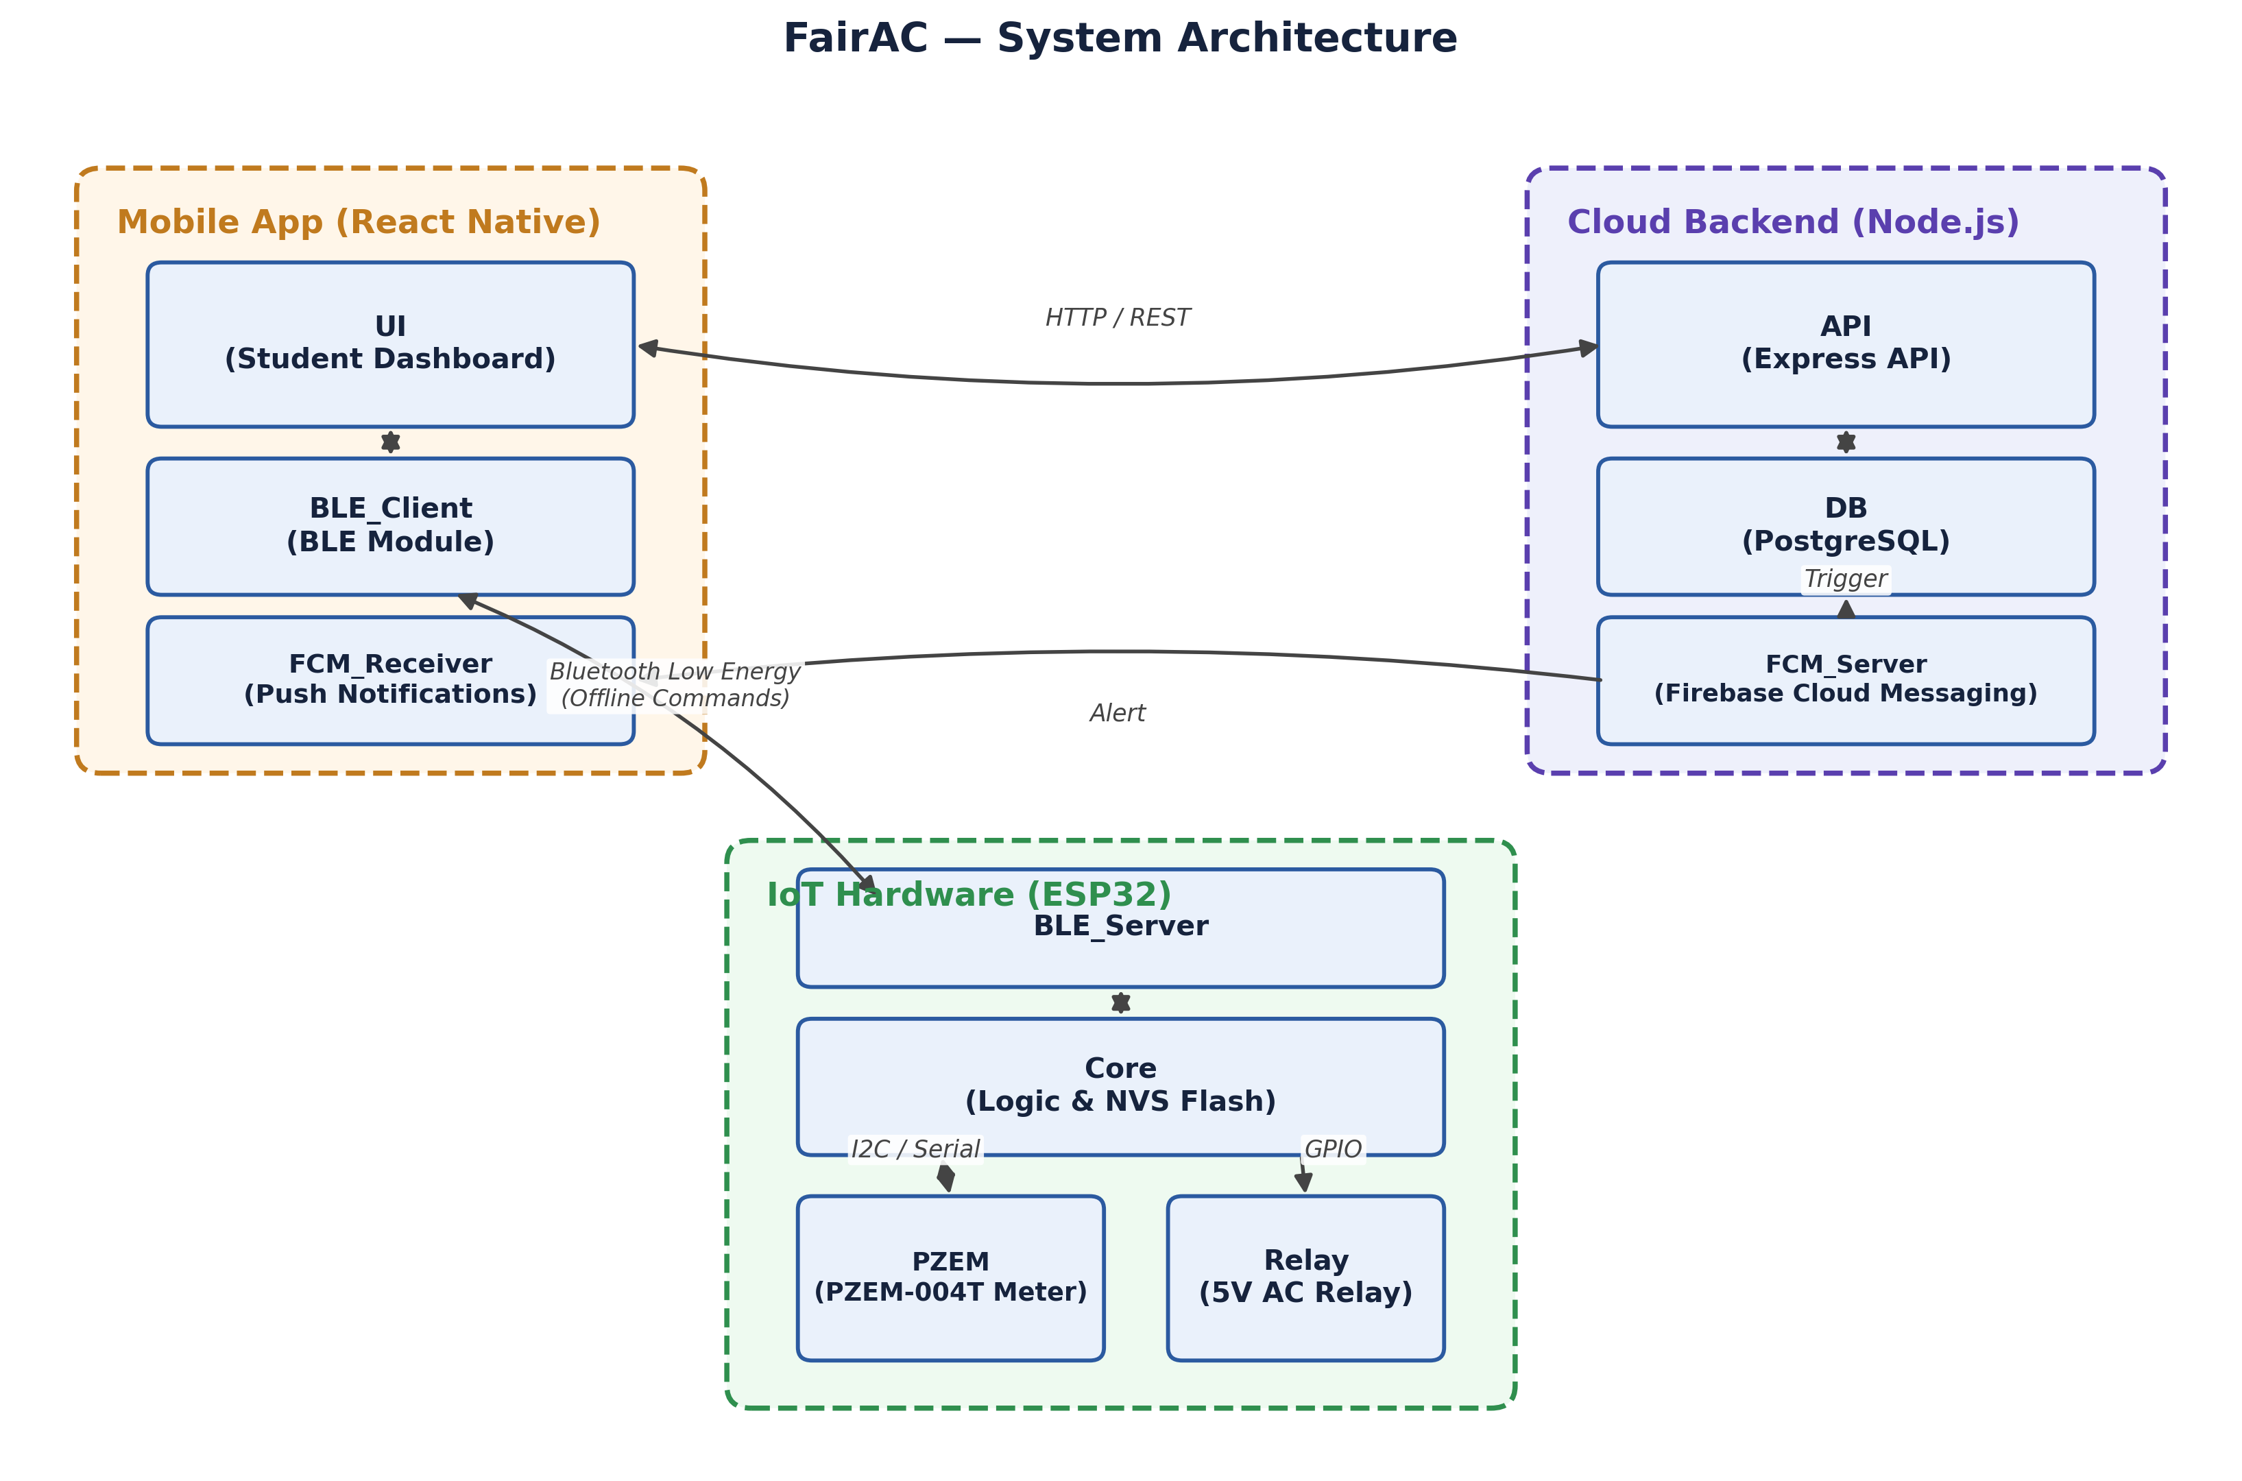
FairAC's three-tier, offline-first architecture: a React Native mobile app bridges the ESP32-based IoT hardware (BLE, offline-capable) and the Node.js/PostgreSQL cloud backend (HTTPS, online), with the ESP32 directly driving the AC relay and reading live consumption from the PZEM-004T sensor.

Appendix B: Version 3.0 — Future Hardware Roadmap (Not Yet Developed)
This appendix documents a tiered hardware architecture designed at the blueprint stage to let FairAC scale across different deployment contexts, from single-room retrofits to centralized, whole-floor installations. None of this hardware has been built or tested; it is included to show the pilot proposed in this document sits within a coherent, scalable long-term design, not as a request for funding beyond the single-room pilot scope defined in Sections 10 and 13.
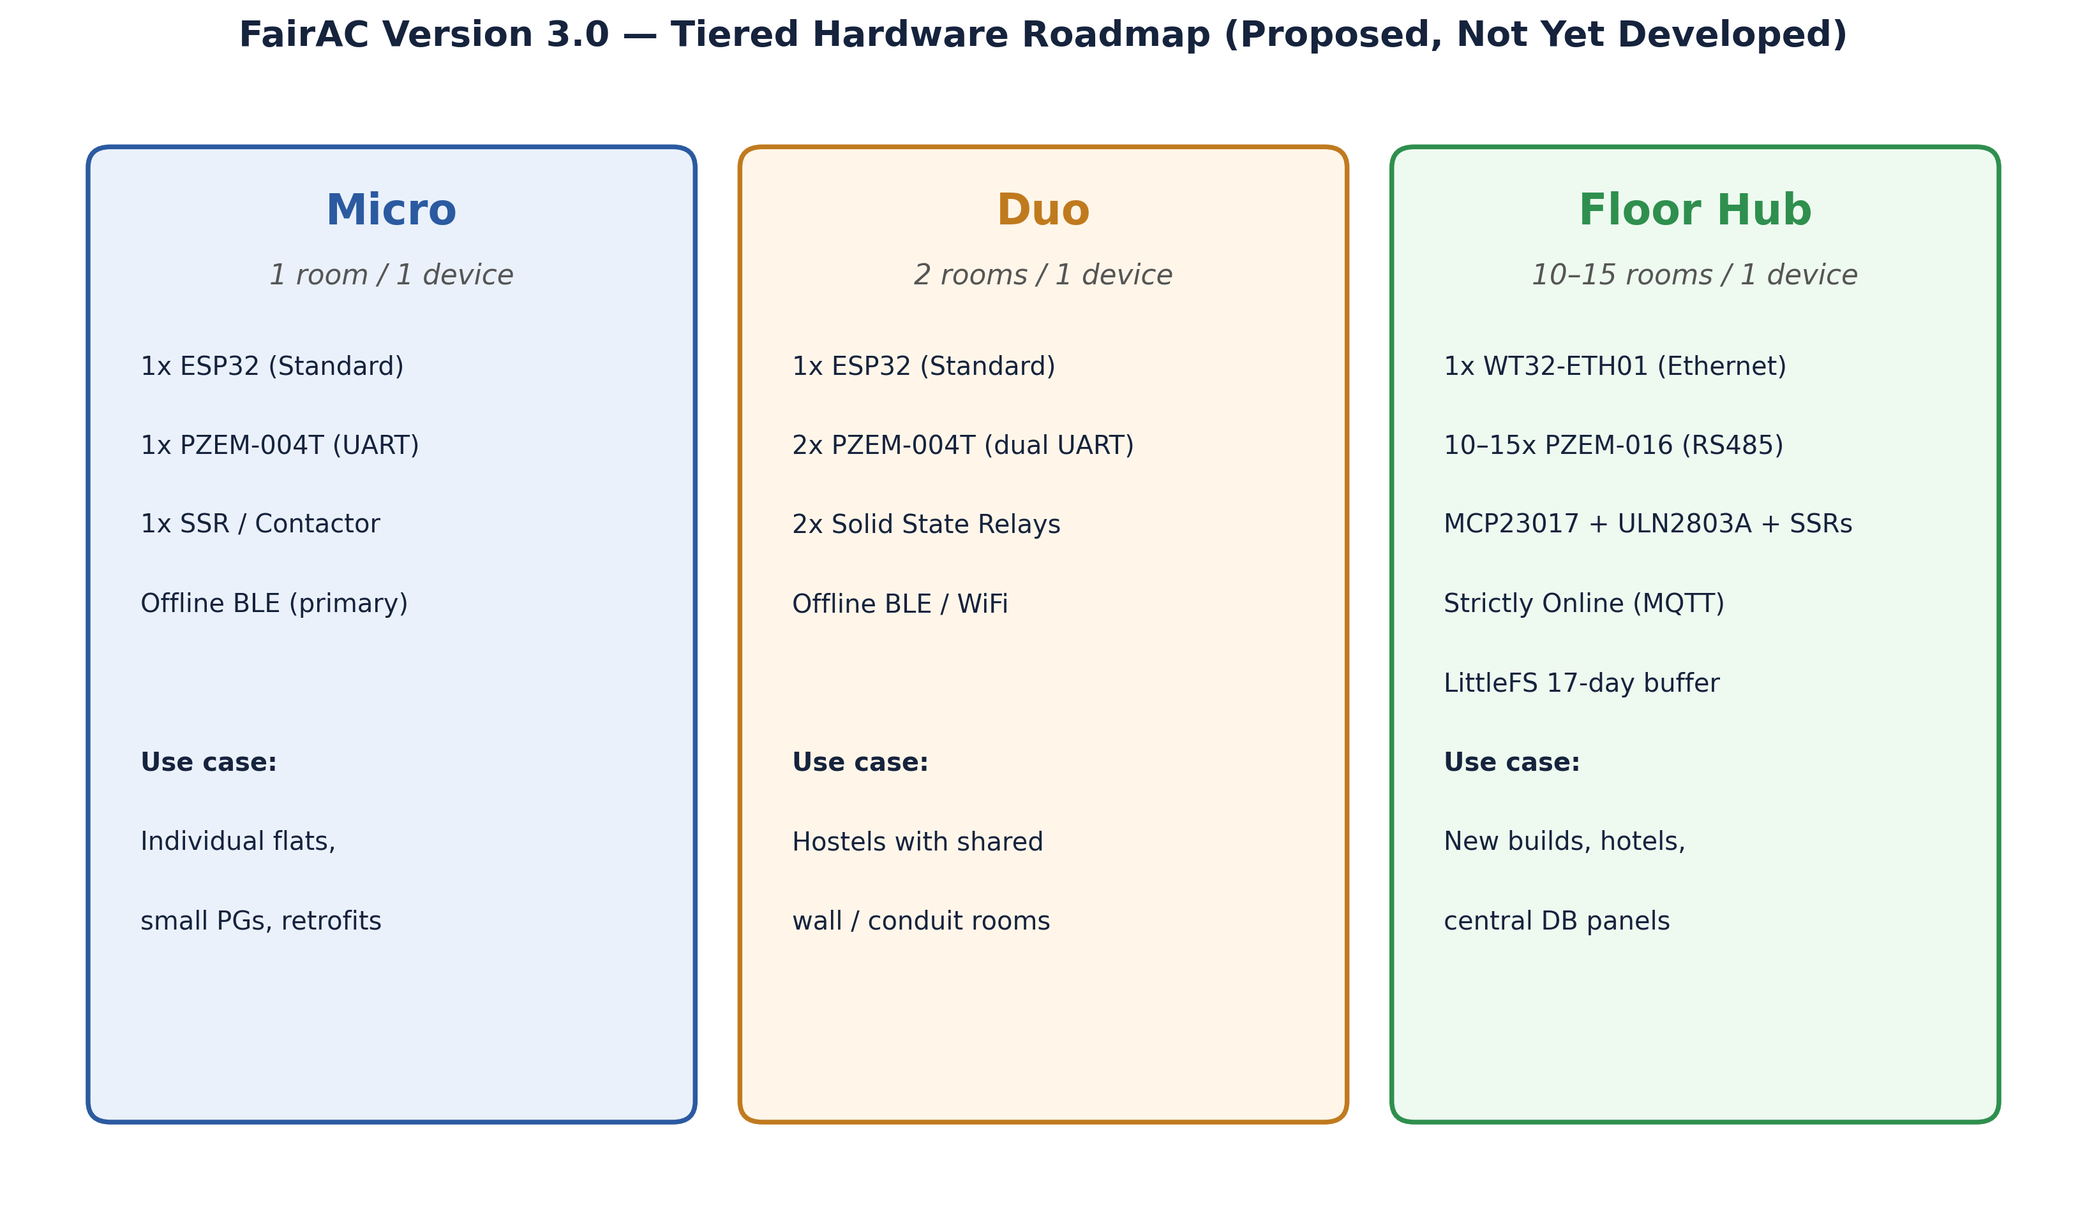

B.1 Shared Backend Principle
All three tiers are designed to share the same cloud backend and PostgreSQL database, with the API accepting session data regardless of whether it arrives via a BLE-connected smartphone (offline path) or directly from an Ethernet-connected controller (online path). This means the pilot's backend work (Sections 6, 10) is not tier-specific — it is designed to remain valid infrastructure even if a later phase moves to the Duo or Floor Hub tiers.

B.2 "Micro" — 1 Room / 1 Device (This Is the Pilot Configuration)
A single ESP32 with one PZEM-004T sensor and one relay/contactor, connected primarily over offline BLE. This is the configuration already implemented and proposed for the pilot in Section 10.

B.3 "Duo" — 2 Rooms / 1 Device (Proposed)
A cost-optimized variant for hostels where adjacent rooms share a wall or electrical conduit: one ESP32 uses both of its hardware UART ports to drive two independent PZEM-004T sensors and two relays from a single controller, reducing per-room hardware cost for that specific building layout. The original design blueprint lists WiFi as a secondary connectivity option for this tier alongside BLE; that WiFi path is unbuilt and unvalidated, so for the purposes of this proposal, Duo is treated as offline-first only, with the same true-remote-control limitation as Micro (Section 8.2), until stated otherwise.

B.4 "Floor Hub" — 10–15 Rooms / 1 Device (Proposed)
A centralized configuration intended for new hostel construction or large buildings where room AC wiring already routes back to a common distribution board per floor. Key design elements:
- Controller: a WT32-ETH01 module (an ESP32 variant with built-in Ethernet) for a wired, strictly-online connection, prioritizing reliability over the offline-first BLE model used at the Micro/Duo tiers.
- Metering: 10–15 PZEM-016 (RS485 Modbus) meters daisy-chained on a single two-wire bus, polled sequentially by the controller.
- Switching: an MCP23017 I2C IO-expander provides the additional output pins needed to drive that many relay channels from just two ESP32 pins, with an ULN2803A Darlington-array buffer between the expander and the relay coils so the low-current digital logic never directly switches the higher-current relay/contactor coils.

B.5 Breadboard-to-PCB Transition
The Floor Hub is envisioned to move from an initial breadboard prototype (off-the-shelf relay modules and jumper wiring) to a custom PCB for any production run, consolidating the optocouplers, ULN2803A array, and relay circuitry directly onto a single board. This is standard practice for moving from a working prototype to a manufacturable product, and is not assumed to happen before the prototype stage is validated.

B.6 Disaster Recovery — Local Flash Buffering (Proposed)
Because the Floor Hub tier is strictly online, losing internet connectivity is a more serious risk for it than for the offline-first Micro/Duo tiers. The proposed mitigation is to use the WT32-ETH01's onboard flash (via LittleFS) as a local buffer: if the backend becomes unreachable, the controller keeps active sessions running normally and logs periodic readings locally instead of losing them. Based on the expected data volume — roughly 20 bytes per reading, 5-minute logging intervals, up to 15 rooms — a conservative 1.5 MB flash allocation is estimated to buffer approximately 17 days of continuous outage before the controller resumes normal server sync automatically once connectivity returns. This figure is an engineering estimate based on expected data volume, not yet validated against a real deployment, and would be confirmed during any future Floor Hub prototyping phase.

B.7 Centralization Trade-off: Single Point of Failure, and Mitigation Strategy
Consolidating 10–15 rooms' metering and control into one controller (Section B.4) is precisely what reduces the electronics footprint described in Section 8.8.1, but it also concentrates risk: if the WT32-ETH01 controller itself fails — not merely loses network, which B.6 already addresses — every room on that hub simultaneously loses both metering and AC control until it is repaired. This proposal treats that risk honestly rather than minimizing it, and proposes the following mitigations rather than full hardware redundancy, which would likely be disproportionately costly at this stage:
- Fail-safe relay default: relay channels default to AC-off, not stuck-on, if the controller loses power or hangs — a hub failure interrupts an active session but can never leave an AC running unbilled and unmonitored.
- Hardware watchdog timer: a standard embedded-systems technique where the controller automatically reboots itself if its own firmware hangs, recovering from the most common failure class (a software fault) without a physical site visit.
- Socketed, field-replaceable controller module: designing the WT32-ETH01 as a swappable module on the PCB rather than a soldered component, so a genuine hardware failure is resolved by swapping one small module rather than replacing the entire floor panel.
- Comparative framing: a Floor Hub failure is not a fundamentally new category of risk — the floor's own electrical distribution board, main breaker, or Wi-Fi router are already single points of failure for that floor's power or connectivity today. The Hub is one more piece of floor-level shared infrastructure with a similar failure profile to infrastructure the building already depends on.
Full hardware redundancy (for example, a hot-standby second controller) is a possible future mitigation but is deliberately not proposed at this stage — it would add cost and complexity disproportionate to a still-unbuilt, unpiloted hardware tier, and is more appropriately evaluated after real-world failure-rate data exists from an initial Floor Hub deployment.

B.8 A Note on Supporting Visuals
PCB layout and enclosure mockups for the Floor Hub concept exist as separate image files generated during design exploration. They are not embedded in this document because they reside on the applicant's local device rather than in any location accessible when this proposal was assembled — the applicant should insert them directly into this section in the editable document before submission, if desired.

